Lab exam 2:

Set i

Subgroup I  
I.1 — [S13I1] Top-3 frequent words  
Scenario (agritech):  
Context:  
Basic text analytics in agritech requires most frequent terms for summaries.  
Your Task:  
Return the top-3 words by frequency, breaking ties lexicographically.  
Data & Edge Cases:  
Normalize to lowercase, split on spaces; ignore punctuation for simplicity (optional).  
AI Assistance Expectation:  
Use AI to propose Counter/ sorting approach and tie-breaking mechanics.  
Constraints & Notes:  
Stable ordering by (-count, word).  
Sample Input  
to be or not to be that is the question  
Sample Output  
[('to', 2), ('be', 2), ('is', 1)]

acceptance Criteria: Tie-breaking lexicographically

I.2 — [S13I2] Generate Docstrings for Crop Yield Function  
Scenario (Agritech):  
Context:  
An agritech analytics team has a function that calculates average crop yield per acre,  
but it lacks documentation. The function works but is not self-explanatory. New  
developers find it confusing.  
Your Task:  
• Write code average crop yield per acre function, that took total_yield and acres  
as input and return average crop yield per acre value.  
• Use AI assistance to generate a clear, structured docstring for the given  
function.  
• Ensure the docstring covers:  
o Parameters (types and meaning)  
o Return type  
o Example usage  
o Notes on edge cases  
Data & Edge Cases:  
• total_yield = 500, acres = 50 → 10  
• Division by zero should be highlighted as a possible error.  
• Input values should be numeric.  
AI Assistance Expectation:  
• Use AI to propose a PEP-257 compliant docstring.  
• AI should also suggest type hints (float for return type).  
• Generate doctests inside the docstring.  
Constraints & Notes:  
• Do not modify function logic, only add documentation & type hints.  
• Keep docstring concise but informative.  
Sample Input:  
print(avg_yield_per_acre(500, 50))  
Sample Output:  
10.0  
Acceptance Criteria:  
• Function includes a proper docstring.  
• Type hints added:  
• def avg_yield_per_acre(total_yield: float, acres: float) -> float  
• Doctest runs correctly.  
• Reviewed for readability and clarity.  
 task1

prompt: create a python for the functional of the user counter lowercase and sort and count of the properly breaking the Tie-breaking lexicographically

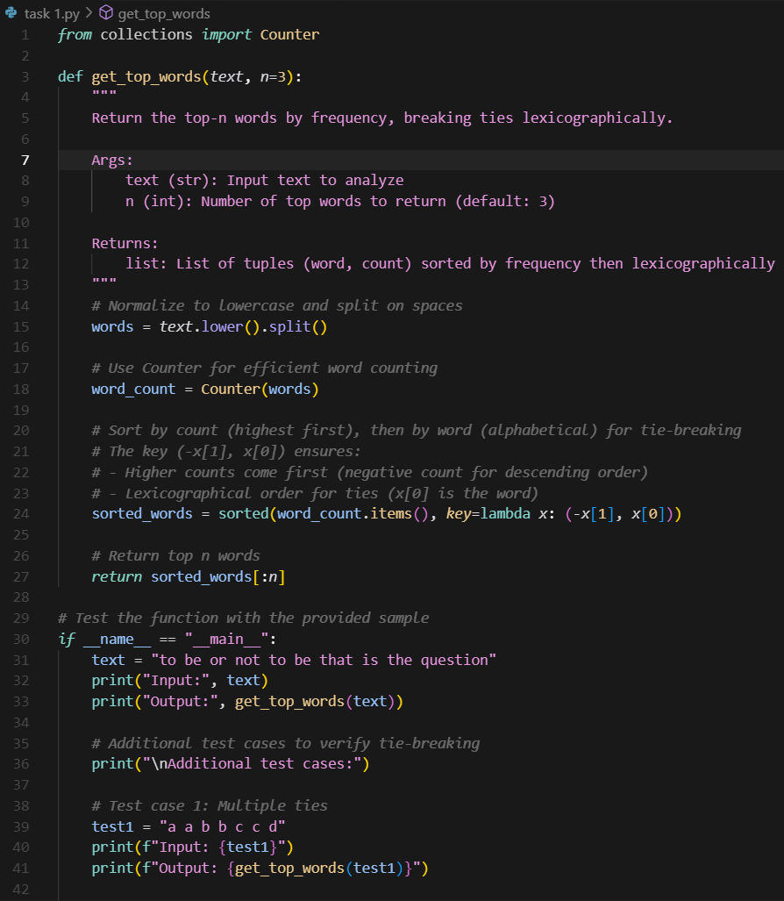

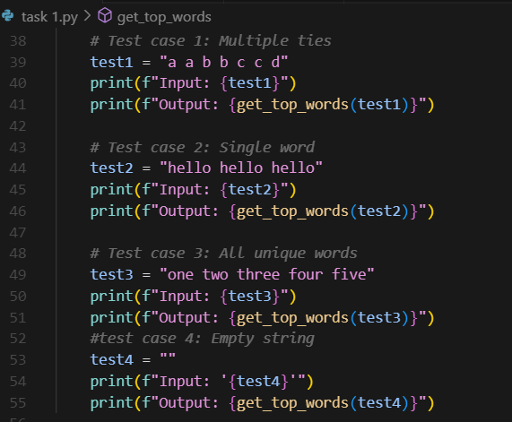

Output:

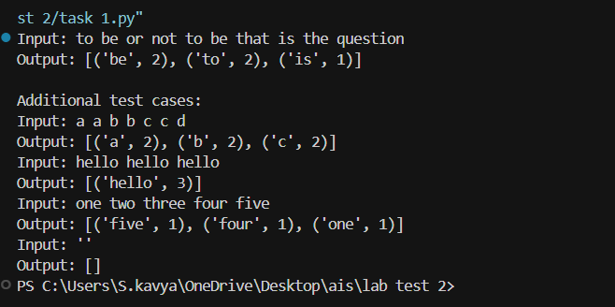

Task2

Prompt : crethe python functional in the average the crop of the agritch average for the avg in the docunments in the per and yield.

